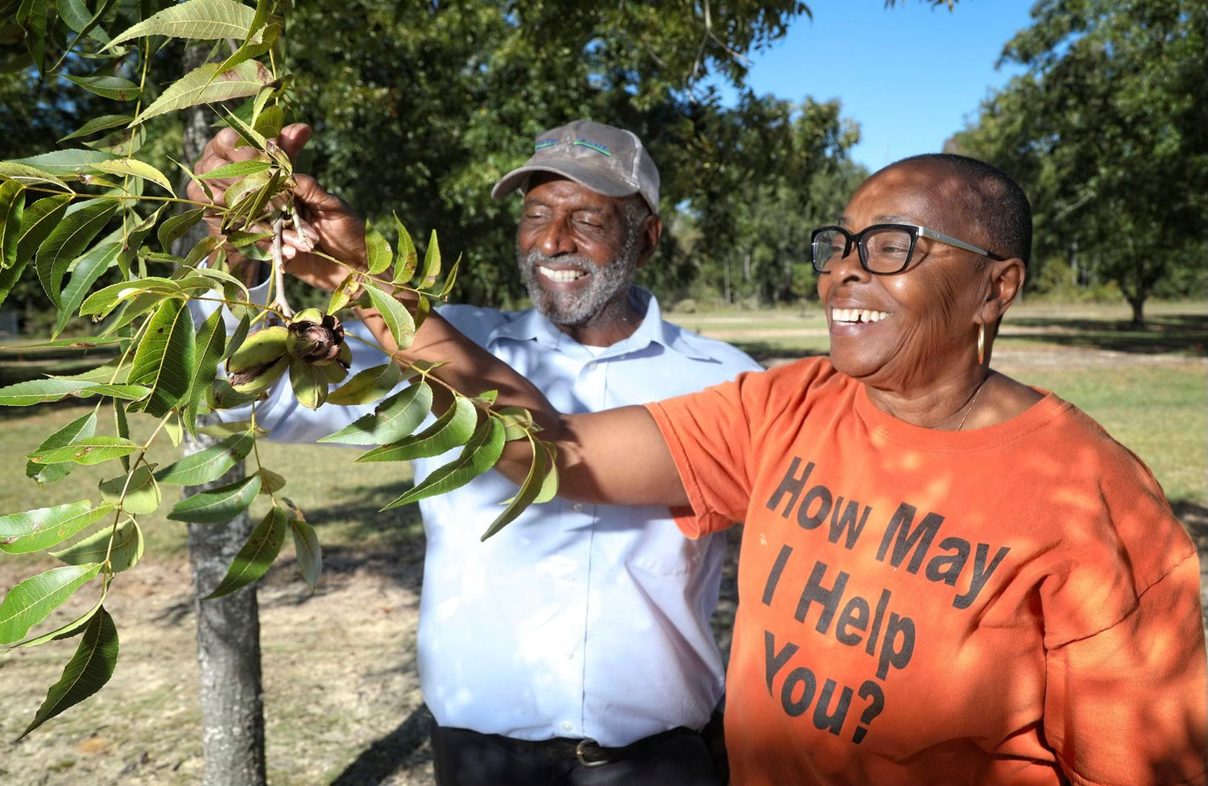

**A realization of faith and a labor of love:**

EKC Farms is always focused and committed to being one of the best Pecan Farms in Southeast Georgia. We are committed to producing and providing delicious high-quality pecans and providing superior customer service. Our mission is part stewards of God’s natural resources and servants to our fellow man.

EKC Farms is a family-owned and operated pecan farm. All our products are produced by hand on-site with a focus on quality, and an attention to detail. We strive for excellence throughout the entire lifecycle of all our pecan products – harvesting, grading, packing, and shipping.